### Measuring gephyrin and ChC-buttons with AIS_point.ijm and ais_point.m

1. Save and install the AIS_point.ijm file in your local path for Fiji macros.
2. Move all the 60x images of a certain brain slice into an empty folder.
3. Open Fiji and run the AIS_point.ijm macro. The flow path of obtaining the AIS data while the macro is running is as follows:
   1. Fiji will pop up a window and you need to select the corresponding10x image of the above brain slice used to get the coordinates of the neurons

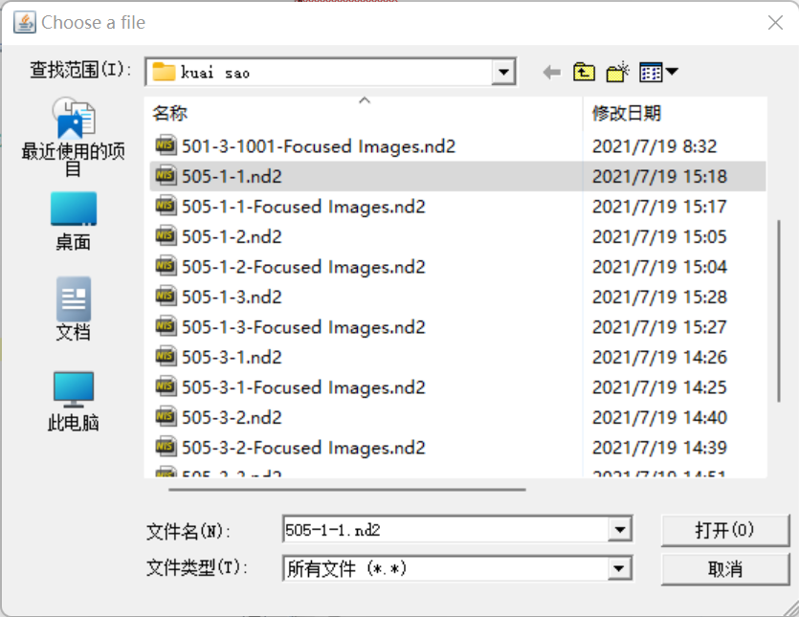

* 1. The next pop-up window requires you to select the file (mentioned in step.2) containing the 60x images used to get the AIS information.

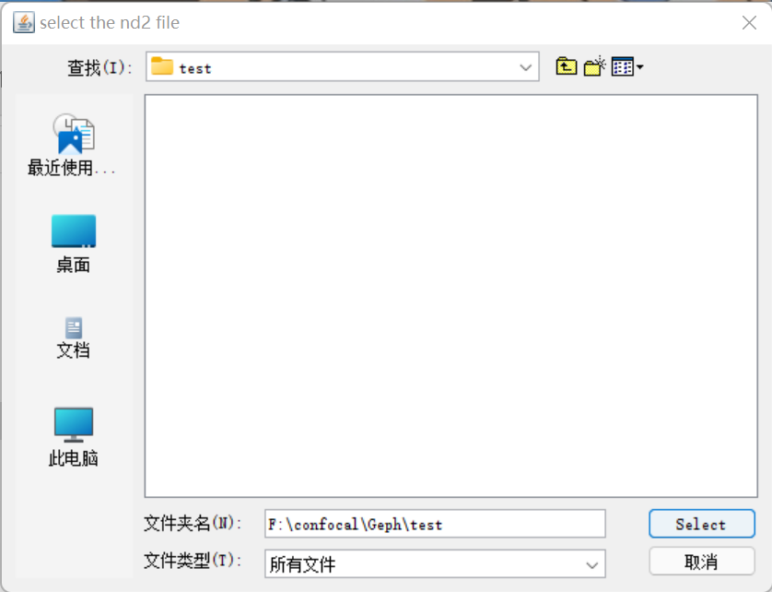

* 1. Wait for Fiji to import and process the 10x image until the window below pops up. Set the “Straight line” in the line toolbox and draw a line along the dorsoventral fissure as the y-axis which starts at the fissure’s apex (the red dot). The coordinate system used to gain the location of the neurons is shown below.

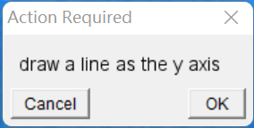

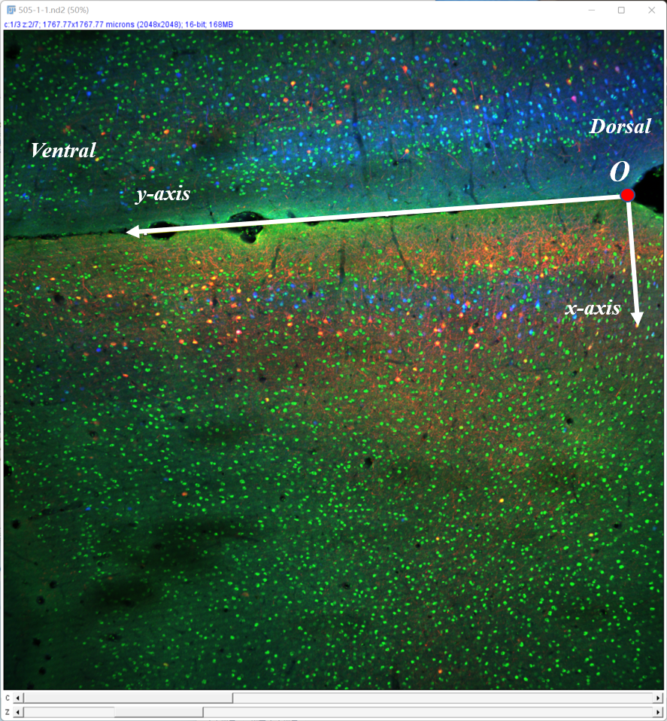

* 1. Wait for Fiji to import and process the 60x image until the window below pops up. The macro will automatically subtract the background of the image using the built-in function “Subtract Background”. Meantime, the macro will also create a max intensity z-projection image from the 60x image stack.

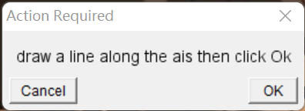

* 1. Set the line width to 3.

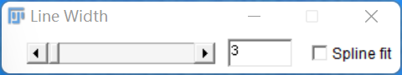

* 1. Choose the “Freehand line” in the line toolbox and draw a line on the z-projection image from the soma to the distal axon with the end of the line exceeding ~5μm of the AIS presented by AnkG staining. Examples are as follows.

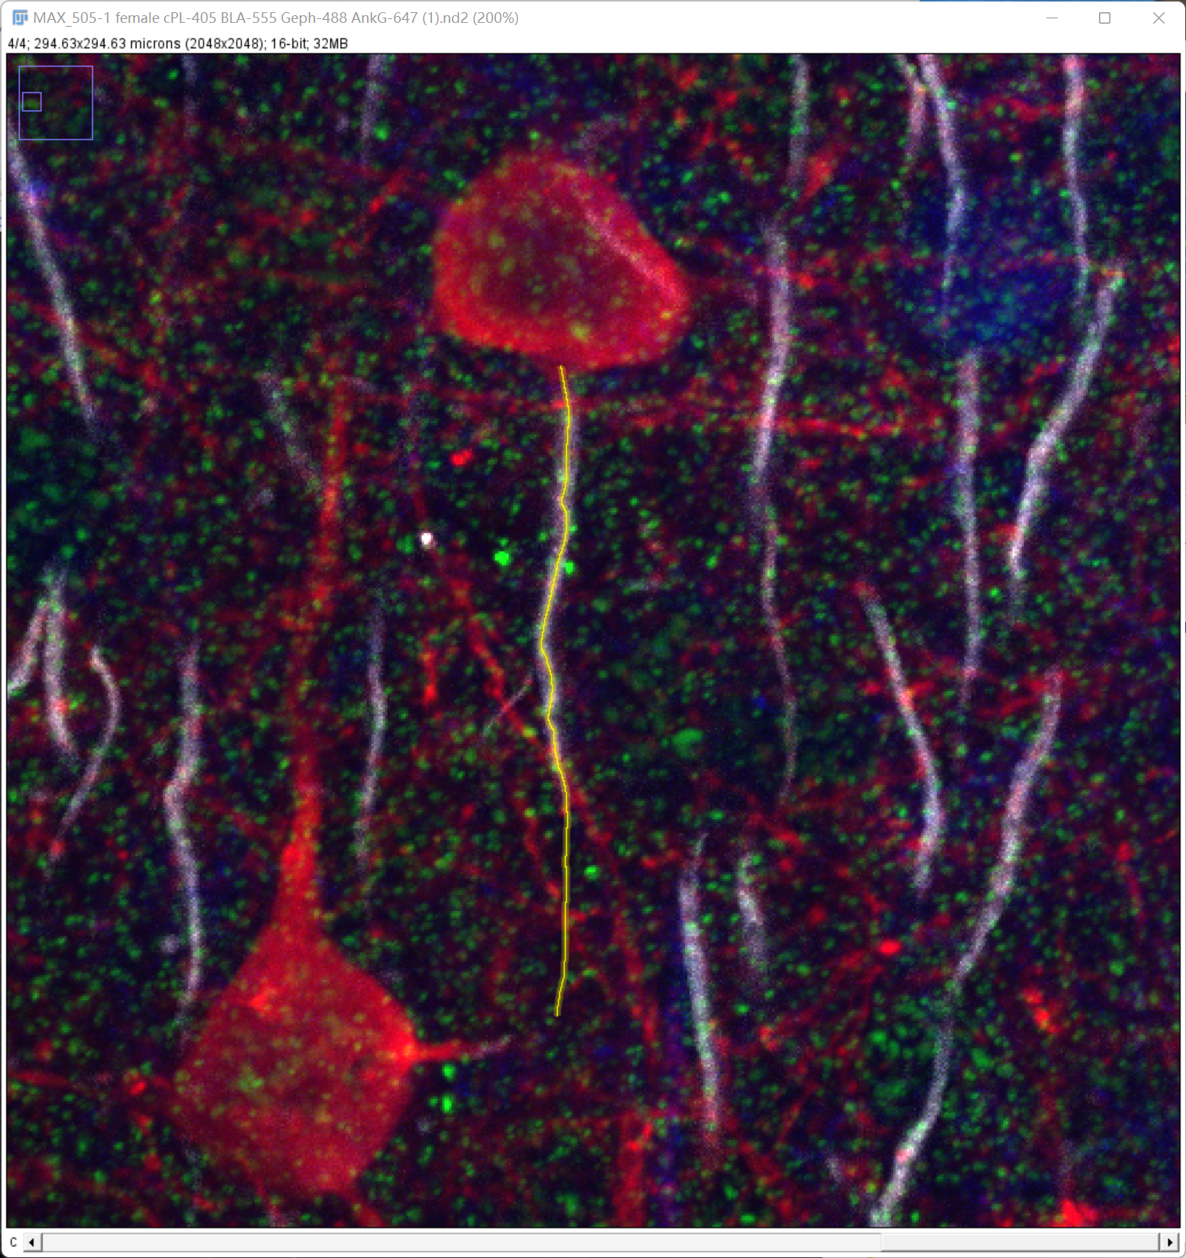

* 1. Click ok in the dialog box below when finishing the drawing.



* 1. Then the line will be drawn on the z-series image. You need to check if the corresponding AIS is intact and click ok in the dialog box below when finishing checking.

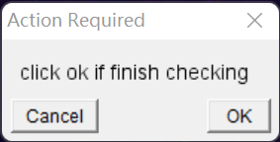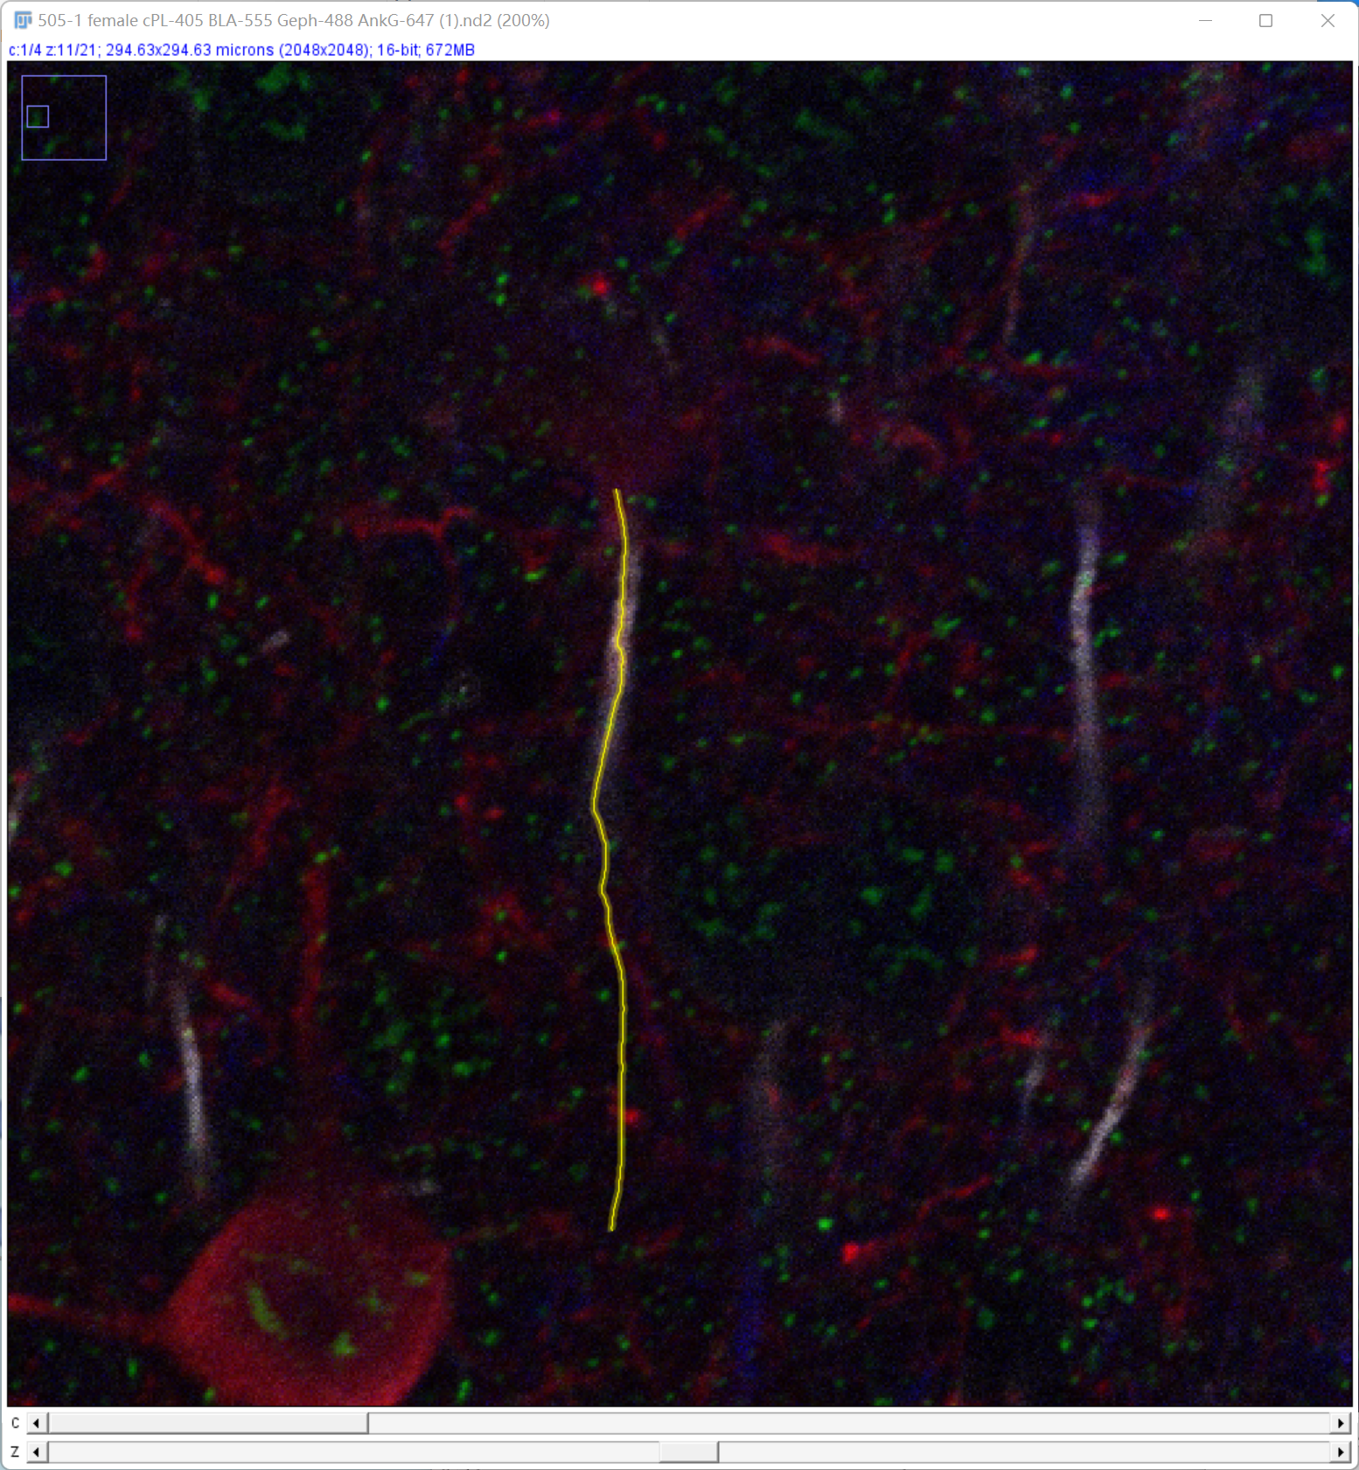

* 1. Fill in the corresponding number in the dialog box that pops up next:
* Fill in 1 if you want to save the data about this AIS and to continue to count other AIS of the image.
* Fill in 2 if you do not want to save the data about this AIS, for example, the AIS is incomplete. Then repeat the f-I steps.
* Fill in 3 if you want to save the data about this AIS and to quit the image, for example, all the AISs have been counted.
* Fill in 4 if you do not want to save the data about this AIS and want to quit the image.

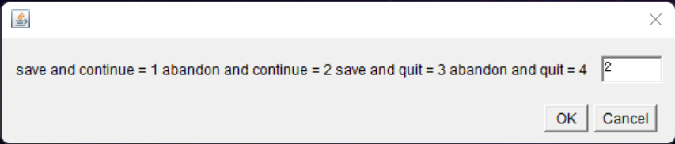

* 1. If you fill in 2 or 3, the macro will then scan all the images in the stack to get the pixel values on the line of each image.
  2. Then you need to choose the “Multi-point tool” and select all the puncta on the AIS and click ok in the box shown below. If there are no puncta on the AIS, click ok as well.

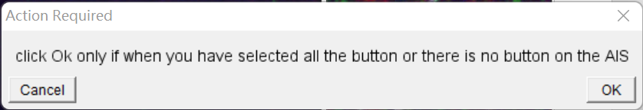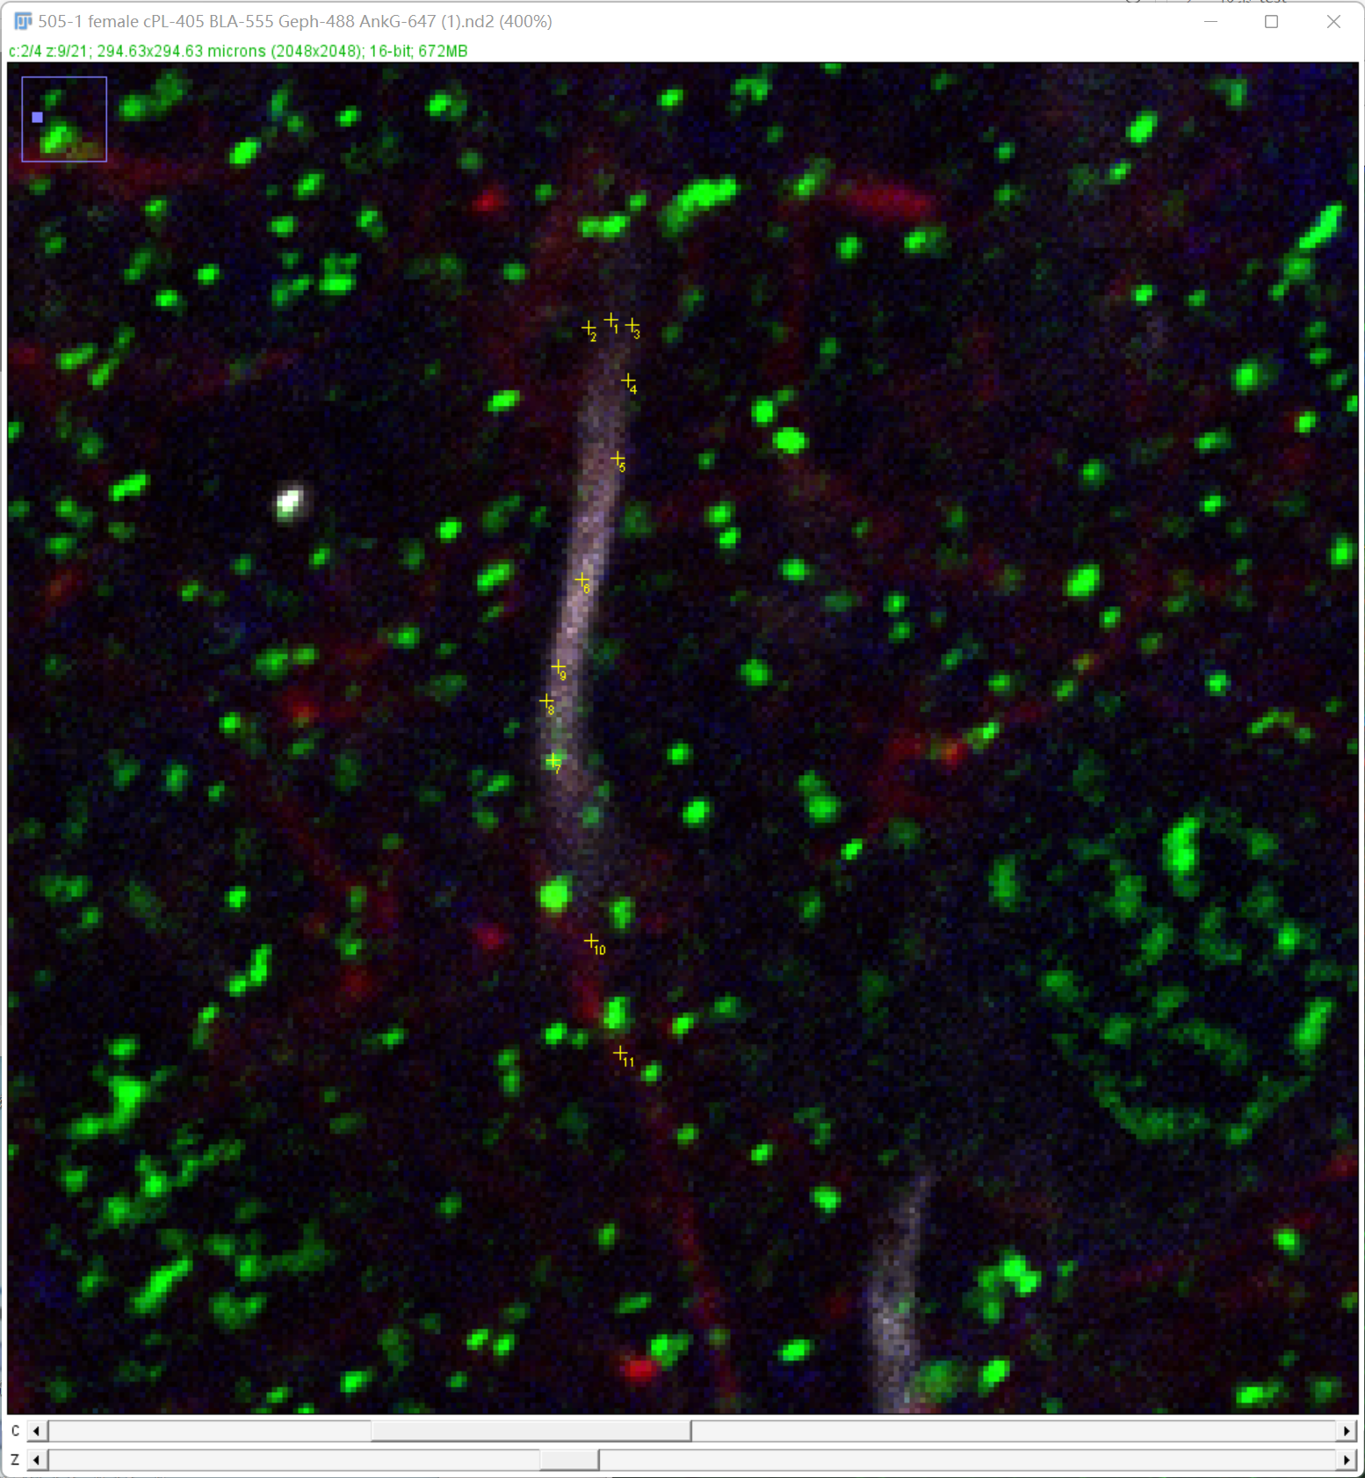

* 1. Next, set the “Straight line” in the line toolbox and draw a line perpendicular to the beginning of the AIS as the width of the AIS. The beginning of the AIS and the width of the AIS is judged by the eye according to the AnkG staining. After finishing the drawing, click ok in the following box.

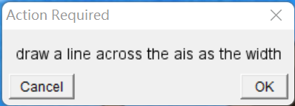

* 1. Then, choose the “Point tool” to select the corresponding neuron in the 10x image (shown in the white circle) and then click ok in the below dialog box.

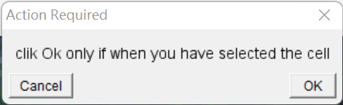

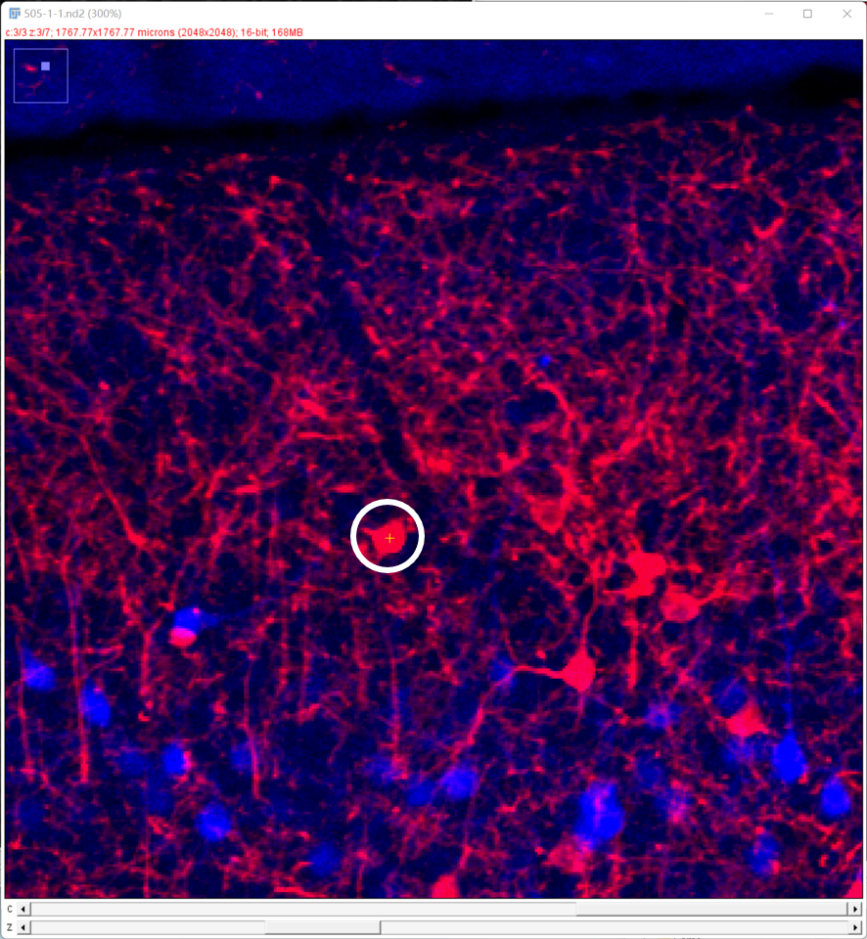

* 1. At last, you need to fill in the corresponding number according to the projection type of the neuron. Specifically, 1 for neurons projecting to cPL and 2 for neurons projecting to BLA.

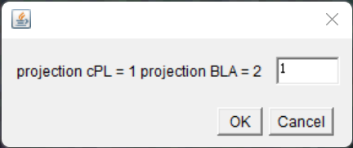

* 1. Repeat the f-n steps until all the AISs are counted.

1. Then, you will get the excels in the folder containing the 60x images. Move the excels to other empty folders for the next steps in Matlab.
2. Save the ais_point.m file in your usual location for Matlab scripts and make sure Matlab knows where to find it (use the 'addpath' function if necessary).
3. Set the folder where excels are stored to the current folder in Matlab and then run the ais_point.m.
4. You will then be required to draw a line profile along the axon as below.

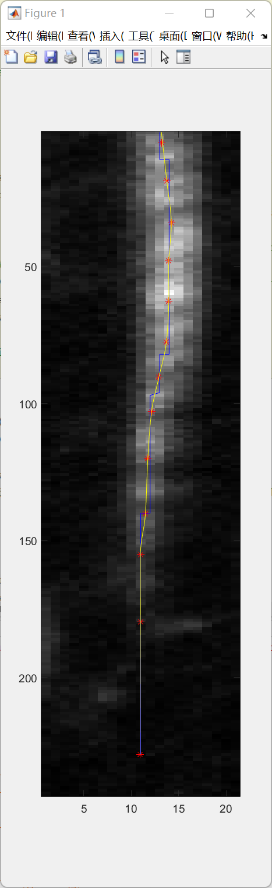

1. After finishing drawing all the axons, you will get two new excels storing the information of AIS. Their file names end in “AIS” and “Profile”, respectively. See below:



* In the “AIS” file, you will obtain the following information about each AIS in each sheet.

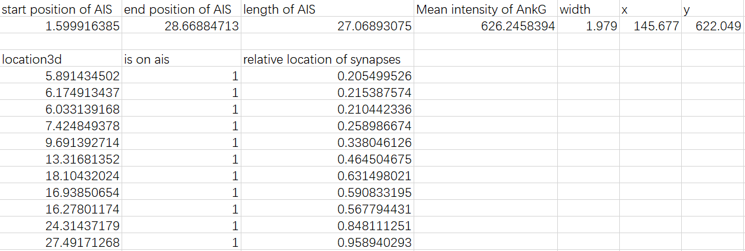

Location3d: the distance to the soma of each punctum.

Is on ais: whether the puncta is on the AIS. If yes, the value equals 1, otherwise, the value equals 0.

Relative location of synapses = Location3d / the end position of AIS.

X and y are the coordinates of the neuron in the coordinate system defined in figure.3c.

* In the “Profile” file, you will obtain the intensity profile of each AIS in each sheet.

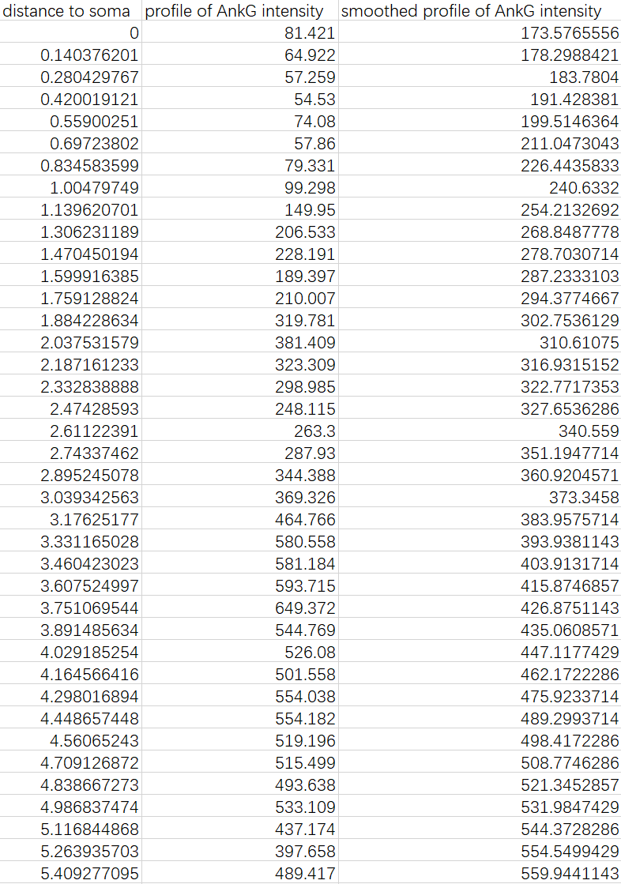

### Measuring proteins of interest, like ion channels, with AIS_line.ijm and ais_line.m

All the steps are the same with the “Measuring gephyrin and ChC-buttons with AIS_point.ijm and ais_point.m” section, except that you do not need to select the puncta.